Expt No:  08 | DC MOTOR SPEED CONTROL SYSTEM
Date:
/ /2025

- AIM:
To control the speed of the PMDC motor using PLC.

- APPARATUS REQUIRED:
- Speed Control Module Trainer (VSAT-01).
- VersaMax Micro PLC.
- Personal Computer [PC].
- VersaPro Software Installed.
- RS - 232 cable.
- Patch Chords.

- PROCEDURE:
- Write your application program in the programming area.
- Store the program to PLC.
- After storing to set the P,I,D values in the PID function tuning Parameters task.
- Right click over the PID function click the Tuning Parameters task.
- Now the PID tuning Parameter control dialogue box appear in the screen. here to set the following values in the particular parameters:
P = 1,
I = 0.1,
D = 0.1 to 7 (Respective your application output oscillation to change the D value),
Sample Period = 0.01 Sec,
Upper clamp = 32000,
SP/PV Range = 32000 M.
- Using patch cards, connect the PLC PWM output to the input of Analog output point in the speed control module trainer kit.
- Using Patch cards connect the speed control module trainer kit analog input to PLC HSC input.
- Run the program
- Set motor speed in PC through a Versapro Software.

- PID IND BLOCK:
The independent algorithm (PID IND) is the close loop control algorithm. The PID function has six input parameters: a process set point (SP), a process variable (PV) , a manual / auto Boolean switch (MAN), a manual mode up adjustment input (UP), and manual mode down adjustment (DN). It also has an address, which specifies the location of a block of parameters associated with the function. It has two output parameters, a successful Boolean output and the control variable result (CV). If the manual input is true, the PID block is placed in manual mode and the output control variable is set from the Manual command parameter %Ref + 13. If either the UP or DN inputs are true, the manual command word is incremented or decremented by one CV count every PID solution. For faster manual changes of the output control variable, it is also possible to add or subtract any CV count value directly fo / from the manual command word.

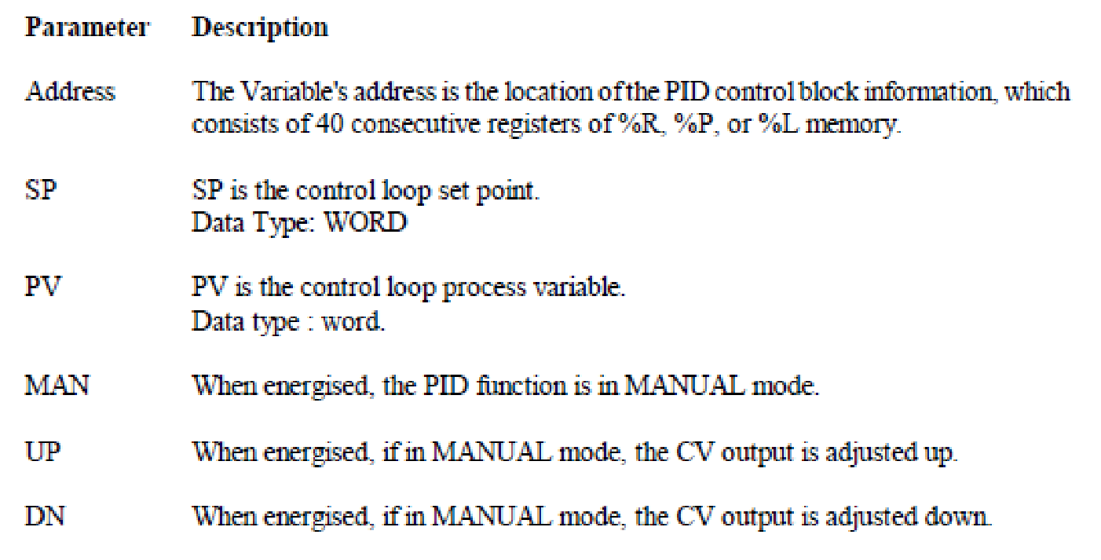
- SCALE INT:
Use this function to scale an input value and place it in an accumulator. This function has five inputs/parameters. For the integer-based version of the function (SCALE-INT) all the parameters be integer based (signed).

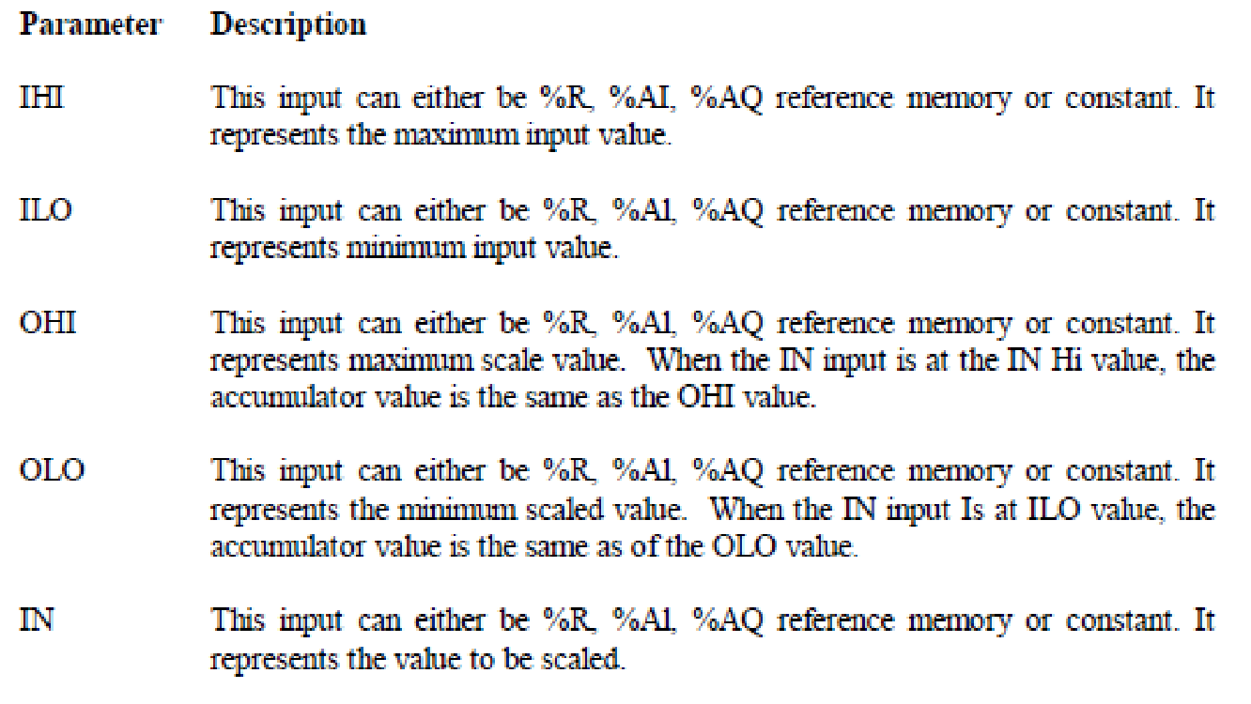
Analog Input to PLC Process Variable (PV) from the 'motor.
Analog output from PLC Control variable (CV) to the motor.
The set point is given to PLC.
The- process variable (PV) from the motor is given as input to the Analog input of PLC. The PLC performs, the control operation and gives the control variable (CV) to control PMDC motor.

- WIRING DIAGRAM:

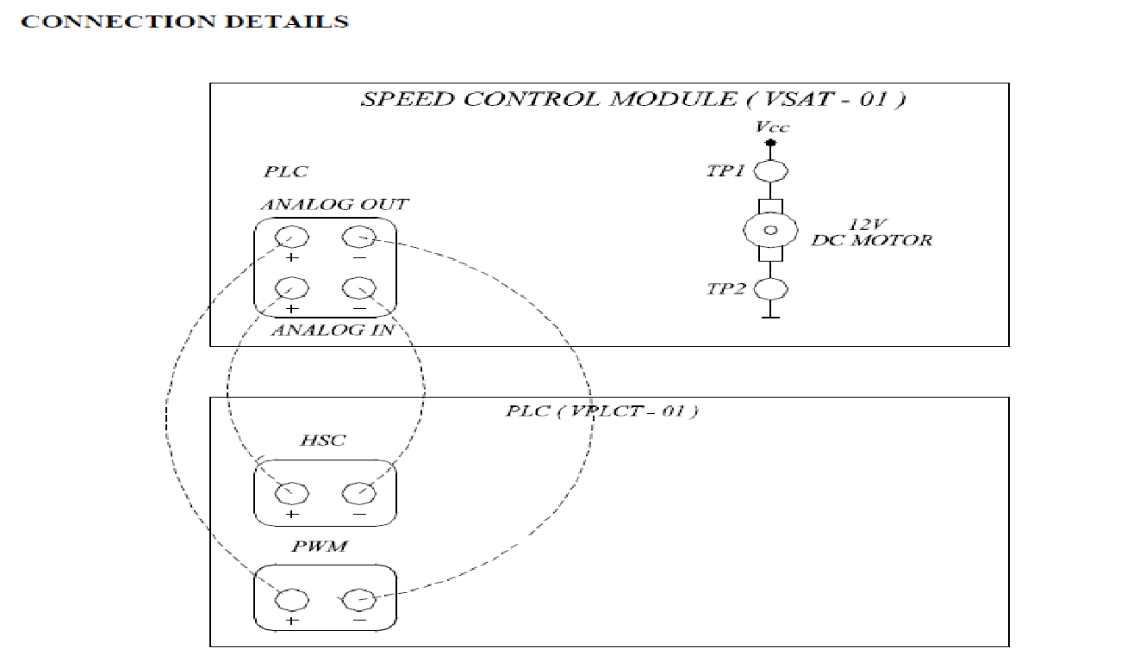
- LADDER DIAGRAM:

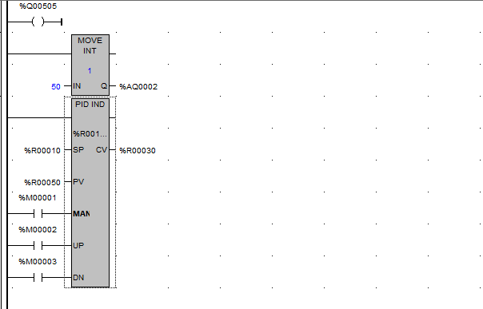

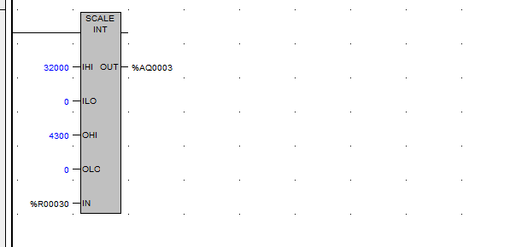

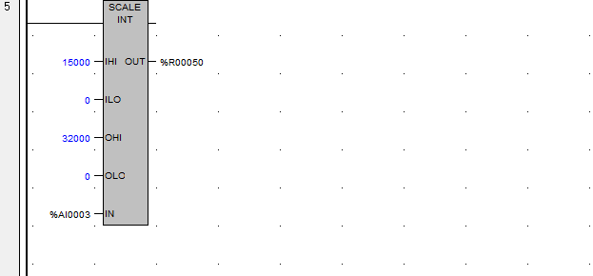

- I/O MAPPING:

- RESULT:
Thus, the speed of the PMDC motor is controlled and verified using PLC.

